Sports Gala 2025
UET LAHORE CS DEPARTMENT
GEAR UP FOR THE MOST EXCITING EVENT


October 25, 2025
JUNAID JAMSHED STADIUM
Kindergarten Student Activities
Here are some fun and engaging activities designed for kindergarten students to help them learn, play, and grow in a different environment
A | 
B | 
C | 
D | 

1 |  |  | 
2 |  |  | 
3 |  |  | 
4 |  |  | 
KINDERGARTEN ACTIVITY  1-Story time | BRIEF DESCRIPTION  Reading colorful picture books aloud to children and asking simple questions. | KEY SKILL DEVELOPED  Imagination, listening skills, and language development |  | PICTURE  
2-Arts and crafts | Using paper, crayons, glue, and scissors to create simple crafts like animals, flowers, or shapes. | Creativity, fine motor-eye coordination |  | 
3-Sing-along and dance | Singing nursery rhymes and dancing to fun tunes. | Memory, rhythm, coordination, gross motor skills |  | 
4-Puzzle play | Solving simple jigsaw puzzles or shape-matching games. | Problem-solving,  Thinking skills, spatial awareness |  | 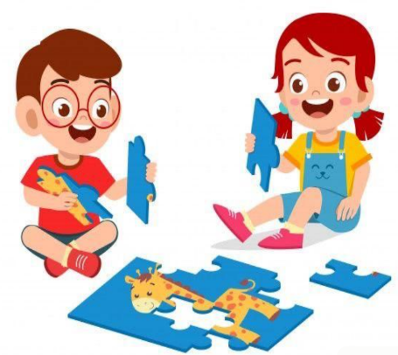
5-Outdoor play | Engaging in activities like running, ball games, or hopscotch. | Physical development, teamwork, gross motor skills |  | 